ReactJS Hands-On Lab
Multiple Ways of Conditional Rendering (bloggerapp)

Objective
The goal of this lab was to explore the various ways conditional rendering can be implemented in React, understand how to render multiple components together, work with list components and keys, and practice extracting components while looping through data with the map() function. I built this using three components — Book Details, Blog Details, and Course Details — each using a different conditional rendering technique.

What I Did
- Created a new React app named "bloggerapp" using create-react-app inside my ReactJS-HOL project folder.
- Created a books.js data file holding an array of book objects (id, bname, price).
- Created a blogs.js data file holding an array of blog objects (id, title, author, content).
- Created a courses.js data file holding an array of course objects (name, date).
- Built the Book Details section using the .map() function with a unique key (book.id) on each list item — this covers list rendering and the importance of keys in React.
- Built the Blog Details section using a ternary operator (condition ? A : B) to conditionally show blog entries or a fallback message if none exist.
- Built the Course Details section using the logical && operator to conditionally render the course list only when courses are available.
- Rendered all three sections together in the same component, side by side, separated by green vertical divider lines using CSS.
- Ran the app with npm start and verified all three sections displayed correctly with their respective conditional rendering logic.

1. Project Setup
I opened the terminal in VS Code, navigated into the ReactJS-HOL/13. ReactJS-HOL folder, and ran create-react-app to scaffold the bloggerapp project.
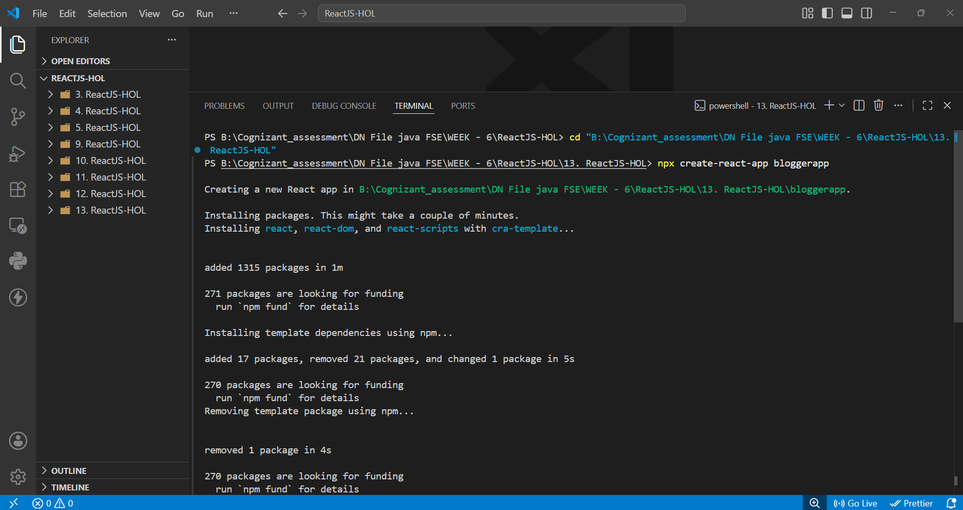
Fig 1: Creating the bloggerapp project with create-react-app
Once the packages finished installing, the project was created successfully inside the correct folder.
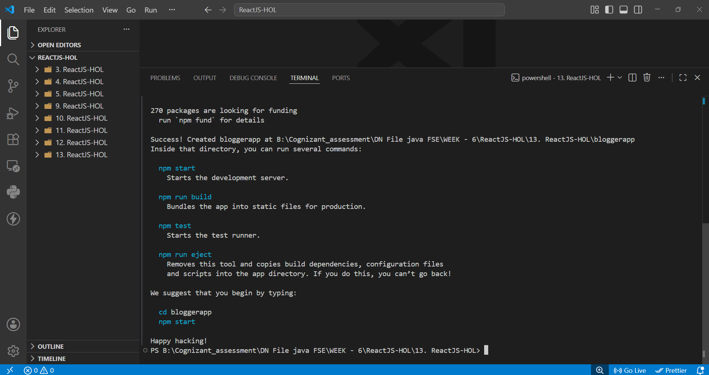
Fig 2: Project created successfully

2. Data Files
I created three separate data files to keep the component logic clean. books.js holds the list of books with id, name, and price.
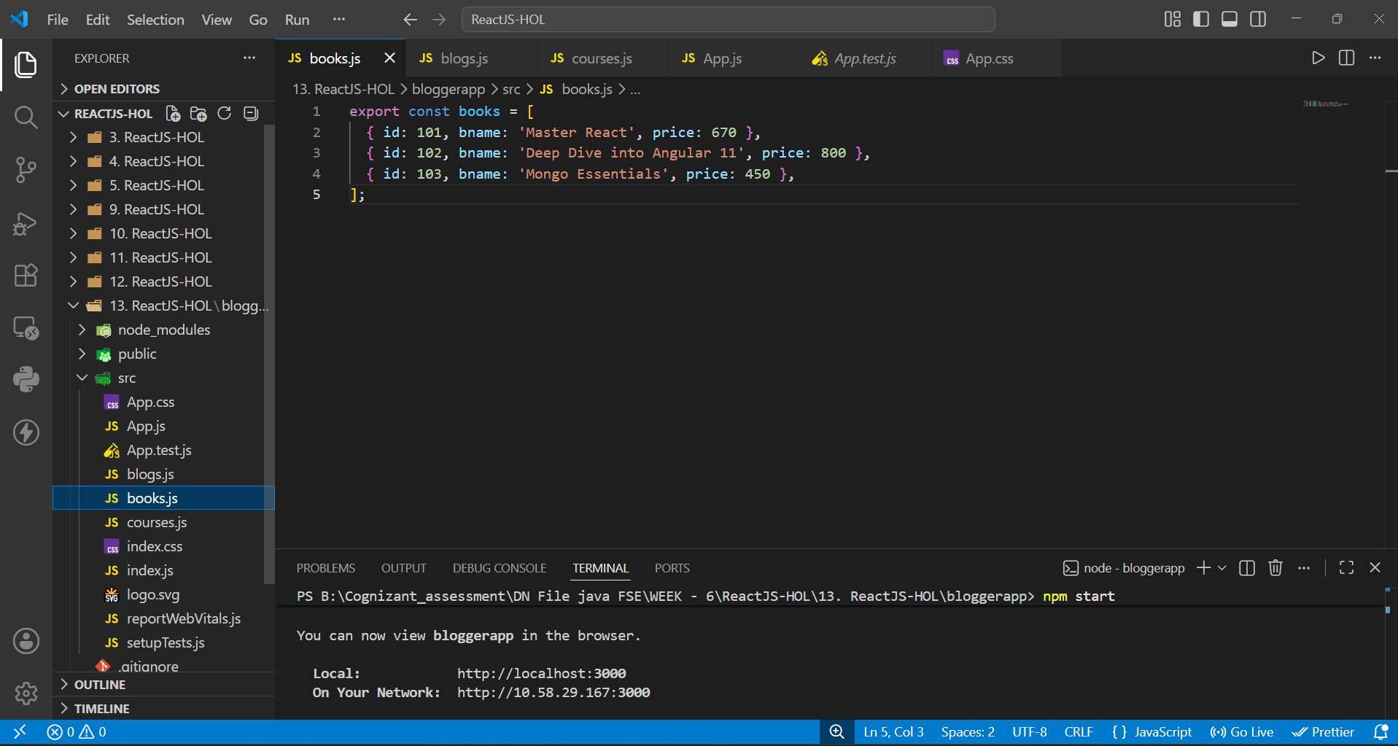
Fig 3: books.js — array of book objects
blogs.js holds two blog entries, each with a title, author, and content — used to demonstrate the ternary conditional rendering.
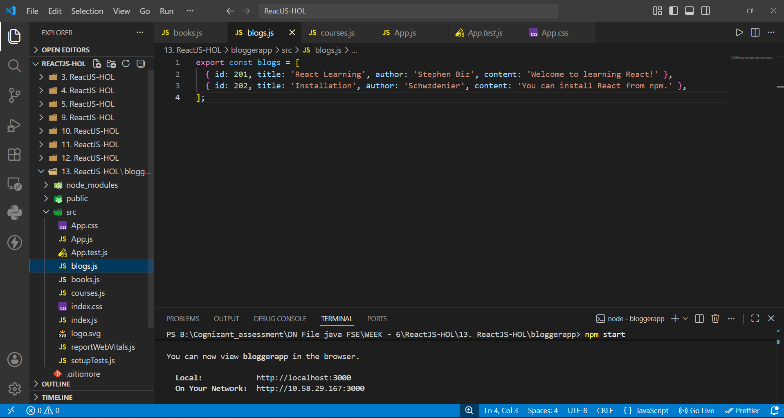
Fig 4: blogs.js — array of blog objects with author and content
courses.js holds the list of courses with their respective dates — used to demonstrate the && operator conditional rendering.
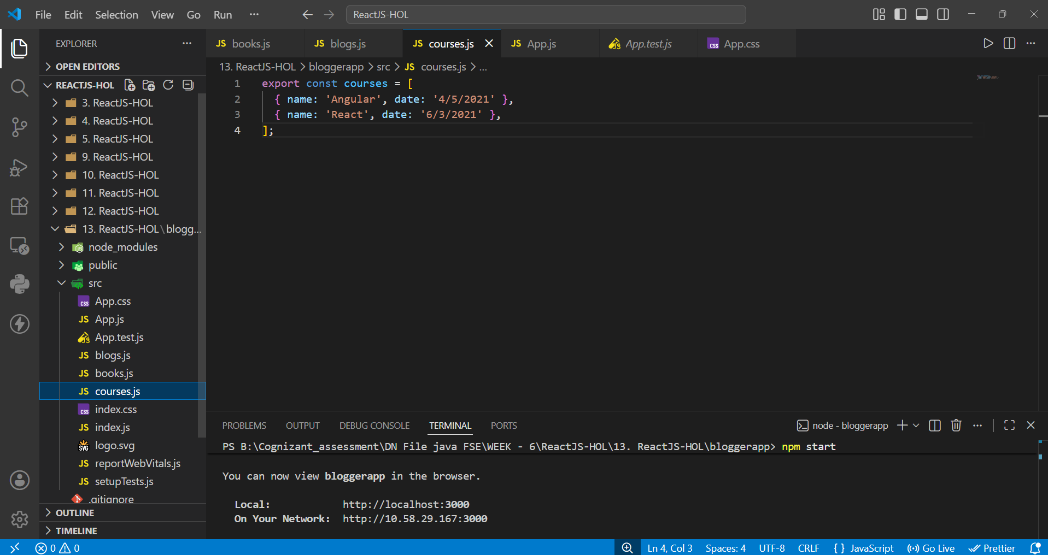
Fig 5: courses.js — array of course objects with name and date

3. Styling
I updated App.css to lay the three sections out in a row using flexbox, with green vertical divider lines between them (border-right), matching the expected layout, and removed the border on the last section.
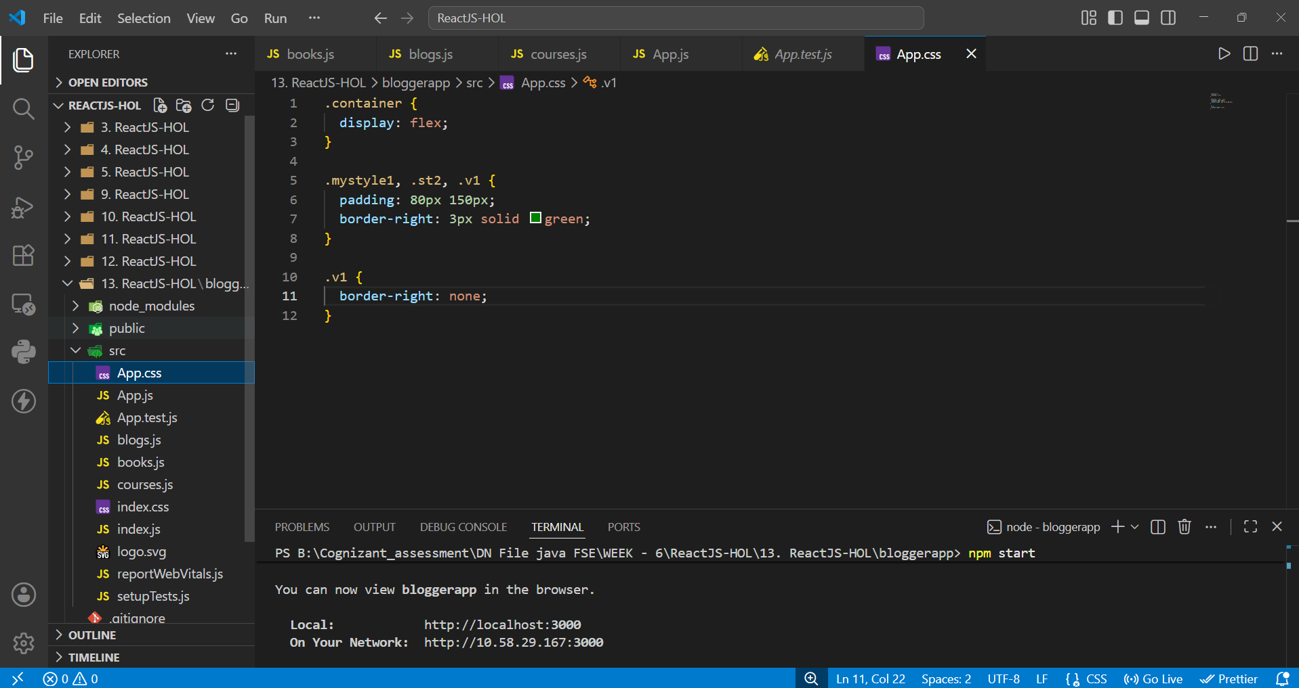
Fig 6: App.css — flex layout with green divider borders

4. Running the App
After writing the App.js code that combines .map() with keys, the ternary operator, and the && operator across the three sections, I ran npm start and the app compiled successfully.
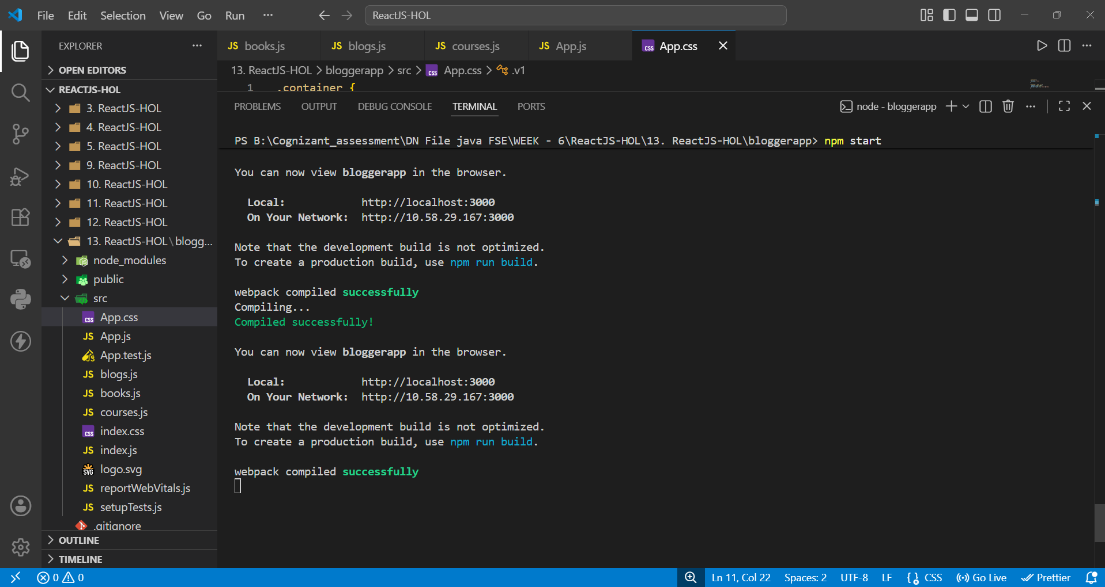
Fig 7: App compiled successfully and running on localhost:3000

5. Final Output
The final page shows all three sections side by side, separated by green vertical lines: Course Details (Angular/4-5-2021, React/6-3-2021) rendered using the && operator, Book Details (Master React, Deep Dive into Angular 11, Mongo Essentials with their prices) rendered using .map() with keys, and Blog Details (React Learning by Stephen Biz, Installation by Schwzdenier) rendered using the ternary operator. This confirms all three conditional rendering techniques worked correctly together.
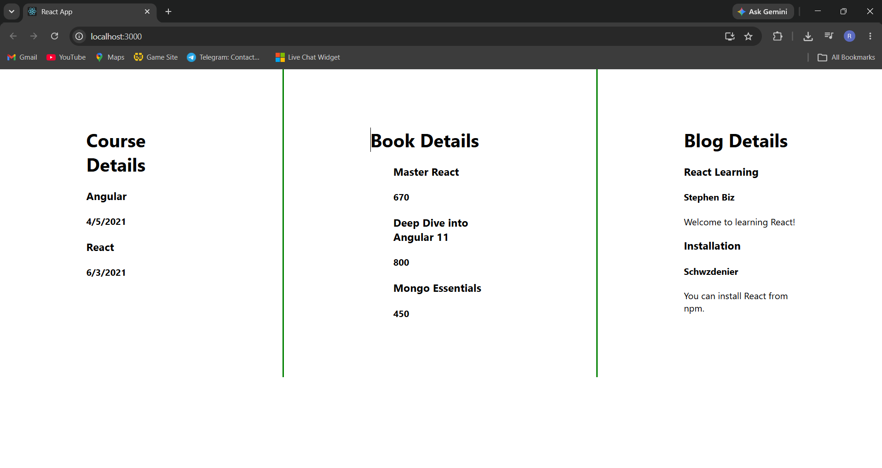
Fig 8: Final output — Course Details, Book Details, and Blog Details rendered together

Conclusion
This lab gave me practical experience with multiple ways of implementing conditional rendering in React — using .map() with keys for list rendering, the ternary operator for either/or rendering, and the logical && operator for rendering only when a condition is true. I also practiced organizing data into separate files and combining multiple independently-rendered sections within a single component.

